BEGINNING OF TERM ONE EXAMINATION 2024
PRIMARY TWO
MATHEMATICS

Time allowed: 1 hour 30 minutes

My name is ______________________________________________
School __________________________________________________

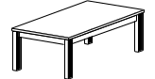
1. Count and write.
(a) = ________

(b) = _________

2. Add correctly.
(a) 7kg + 5kg = _________ b) 3 4 kg
+ 2 3 kg

3. Write in words.
(a) ½ = ______________________
(b) 48 = ______________________

4. Make new sets from a big set.



5. Subtract.
(a) 10 litres – 4 litres = (b) 4 8 litres
- 2 5 litres

6. Work out.
(a) 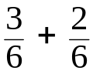 =

(b) 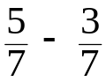=

7. Complete the abacus.
(a) T O (b) T O

3 5
___ __ = __________
__________

8. Multiply.
(a) 4 (b) 2 2
x 3 x 2
_____ _____

9. (a) Name the shape. (b) Draw a triangle.

_______________
10. Fill in the missing numbers.
(a) 1st, 2nd, ___, 4th, 5th, ___, 7th, 8th

(b) 65, 66, ___, 68, ___, 70.

11. Fill in the missing numbers.
(a) + 3 = 8

- - 3 = 3

12. Fill in the missing tens and ones.
(a) 24 = ___tens ___ones.

(b) 8 tens 3 ones = _____

- _____ = 9 tens 0 ones.

13. Divide/Share.
(a) 9 ÷ 3 = (b) 2 14 =

14. Write in figures.
(a) Second = _________ (c) Sixty three = _______
(b) A quarter = ________
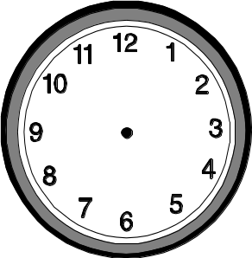
15. (a) What is the time? (b) Show the time.

____________________ It is 4 o’clock.
16. Expand these numbers.
(a) 26 = _____ + _____
(b) 76 = _____ + ____
(c) ___ = 30 + 4

Read and answer.
17. Paul bought a book at shs. 700 and a pencil at shs. 200. How much money did he spend altogether?

18. How many ears do seven men have?

19. Tom had 13 litres of milk. He poured 6 litres.
How many litres were left?

20. Share ten sweets equally between two girls.
How many sweets does each girl get?

21. Use a number line to work out.
(a) 2 + 5 = ___

- 1 2 3 4 5 6 7 8 9 10

(b) 9 - 3 = ___

0 1 2 3 4 5 6 7 8 9 10

22. Which container holds more or less?

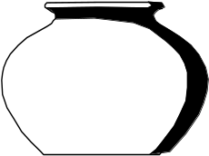

tin
Pot
- A ____________ holds more water.
- A ____________ holds less water.
23. Study the price list and answer the questions.
A sweet A cake An orange

Sh. 200 sh. 700 sh. 300
(a) What is the cost of a cake?
________________________________________________
(b) What is the cheapest item?
_________________________________________________
(c Find the total cost of a cake and an orange.

24. Study the graph and answer the questions.
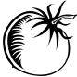
Musa Tom Ali Sam
(a) Who picked the least number of tomatoes?
_________________________________________________
(b) ___________ and __________ picked the same number of tomatoes.
(c) How many tomatoes did they pick altogether?
End

